# CS 255 System Design Document Template

This template lays out all the different sections that you need to complete for Project Two. Each section has guidance to prompt your thinking. You will need to continually reference the interview transcript as you work to make sure that you are addressing your client’s needs. There is no required length for the final document. Instead the goal is to complete each section based on what your client’s needs are. Remove this note when you are finished, and replace all bracketed text with the relevant information.

## UML Diagrams

### UML Use Case Diagram

### UML Activity Diagrams

# User Manages Appointments

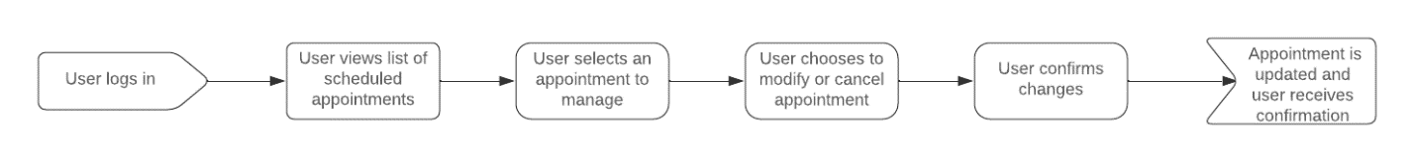

# User Schedules Appointment

### UML Sequence Diagram

### UML Class Diagram

## Technical Requirements

Based on the functional and non-functional requirements, here are the technical requirements for the proposed system:

# Hardware

* **Server**: High-performance server for hosting the application.
* **Client Devices**: Computers, tablets, or smartphones for users to access the system.

# Software

* **Operating System**: Windows Server, Linux, or macOS for the server.
* **Web Server**: Apache or Nginx.
* **Database**: MySQL, PostgreSQL, or MongoDB.
* **Development Tools**: IDEs like IntelliJ IDEA, Visual Studio Code.
* **Web Framework**: Django, Flask, or Spring Boot.

# Infrastructure

* **Network**: High-speed internet connection.
* **Security**: SSL certificates for secure communication, firewall, and antivirus software.